**MIDDLE EAST TECHNICAL UNIVERSITY**

**DEPARTMENT OF ELECTRICAL & ELECTRONICS ENGINEERING**



**TROY TECH**

**WEEKLY REPORT #3**

**18.03.2019-22.03.2019**

**Section :** 7

**Studio Coordinator:** Mustafa Mert ANKARALI

**Partners :**

Hasan ÖZKARA - 2031888

Kağan ÖZASLAN - 2031854

Caner POTUR - 2031250

Mustafa Ercan OKATAN - 2031193

Mert KAYIŞ – 2030997

**Progresses for Previous Week:**

Last wee we did the whole design from the beginning since we use one size bigger

solenoid. Also, we decided the places of mounting holes and arrange the sizes.

For design progress. we sent the necessary mounting parts to the producer including motor holder, battery holder and shooter plaque. Also we bought the mounting miles and screws which we need.

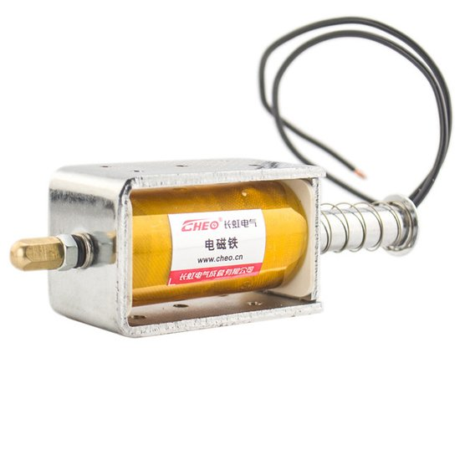

Figure 1: 33mm stroke solenoid

We tried the circuit of shooting system and we ordered bigger capacitors which are 10000uF. We also tried the 15A relay and NPN transistor for switching. The circuit operated well and we are going to finish the circuit implementation.

We got the signal booster amplifier for video transmission and we have done tests some, for further progress we are going to end the tests and observe the improvements.

**Plans for Next Week:**

1. Order body and implement it.
2. Try new capacitors and implement shooting system onto body.
3. Implement all subsystems on the robot with a Arduino mega.
4. Improve command control for controlling robot.